Author: Jessica Stephenson

Koloane, David

David Koloane is an important South African artist, critic, curator and educator born in Johannesburg in 1938. From 1974 to 1977 he studied at the Bill Ainslie Studios; thereafter he dedicated himself to improving access to modern art education for black artists. Koloane partnered with Bill Ainslie on a number of projects, including establishing the Gallery in 1977, the first black-run exhibition space for modern art in Johannesburg. He is a leading black educator, teaching at Fuba Academy in the 1980s. He received a diploma in museum studies at the University of London (1985) and became one of the first black curators in South Africa. From 1986 to 1988, he was curator of the Fuba Art Gallery in Johannesburg, which housed a collection of international modern art; he co-curated the Zabalaza Festivals in London in 1990, and he also co-curated the exhibition Seven Stories About Modern Art in Africa at Whitechapel Gallery, London in 1995. Koloane’s attendance at the 1983 international Triangle Artist Workshop in New York led to the founding of the important Thupelo Workshops in South Africa. In 1991 Koloane helped establish the Speedy Bag Factory in Johannesburg, the first professional artist studio space dedicated to combining cultural diversity with university educated artists. The Speedy Bag Factory continues to be an important platform for contemporary art in post-apartheid South Africa.

Koloane’s art – paintings, drawings and prints – depicts the chaos, energy, pain and intensity of apartheid and post-apartheid urban landscapes. His subject matter draws on the spaces, traffic, mass protests, fighting stray dogs, soccer mania, jazz music and detritus of urban townships. While these topics resonate with the work of black township artists of the 1960s and 1970s, Koloane’s work is suggestive, subtle, and expressive by contrast with the representational and sometimes romanticized depictions characteristic of earlier forms of township art. He has exhibited widely both within South Africa and abroad, and his work is represented in major collections including the Iziko South African National Gallery, Cape Town, the Johannesburg Art Gallery, University of Witwatersand Art Galleries, Johannesburg, the Botswana National Museum, the Contemporary African Art Collection of Jean Pigozzi, the BMW Collection, Germany, and the Franka Severin Collection, London. Recognition for his contribution to art in South Africa was made by the Dutch government with the Price Claus Fund in 1988. Koloane lives and works in Johannesburg, and is currently a board member of the National Arts Council of South Africa.

References and Further Reading:

Koloane. D. (2004) “Traversing and Transcending Spaces: The Roles of the Artists’ Workshop and the Collective Studio in Contemporary South Africa” in Gary van Wyk (ed.), A Decade of Democracy: Witnessing South Africa. Johannesburg: Sondela.

Koloane. D and Ivor Powell (1995) “ In Conversation” in Seven Stories About Modern Art in Africa, edited by Clementine Deliss. Paris and New York: Flammarion, 140 – 156.

Peffer, J. (2009) Art and the End of Apartheid. Minneapolis: University if Minnesota Press, 129 – 170.

Tadjo, V. (2002) David Koloane. London and New York: David Krut Publishers.

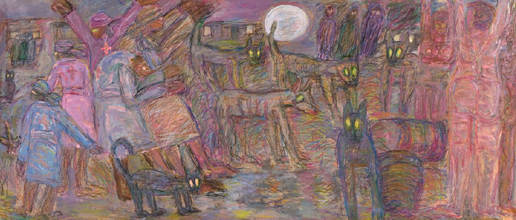

Image caption:

The Night Has a Thousand Eyes. 2007 – 08. Mixed media on paper.

Source: http://www.saatchigallery.com/artists/artpages/david_koloane_the_night_has_a_thousand_eyes.htm

